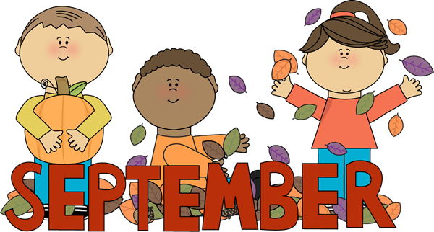

**First Grade’s Classroom News!**

**Reminders**

* **Please send your child’s binder back to school daily.** It’s our main line of communication between home and school. Check your child’s conduct sheet and initial daily
* **Whenever you change transportation please send a letter with a date and signature. (**Put it in the binder, **NOT** in your child’s backpack.
* Parents, **PLEASE** put a light jacket in your child’s backpack, because the classroom can get a little cold.
* **ARRIVAL TIME:** Students needs to report to school on time. No later than 7:25 AM. After 7:30 AM, your child will be considered **TARDY**.
* **DISMISSAL TIME:**

We will dismiss all car riders and walkers @ **2:10 PM. *Please be on time for pick-up!***

* In addition, if your child rides the bus, please be mindful that a parent or guardian must be outside when the bus stops @ the designated stop area.
* Parents if you are not outside when the bus drops off your child, the bus driver will bring them back to school & you will have to pick them up.

**Curriculum Updates**

* *Parents* ***please*** *work with your child nightly on ALPHABET RECOGNITION/SOUNDS & Sight Words. (Alphabet Chart & Sight words in Binder.)*
* ***ELA (English Language Arts)****- Short a, short e, short i, short o, short u & l- blends.*
  + *Ask and answer questions about a text*
  + *Use illustrations and details in a text and write informative text.*
* ***Math –*** *Counting**to 120 from any number.*
  + *Counting by 10’s to 120.*
  + *Adding & Subtracting within 20.*
* ***Reading-*** *Read nightly and record information in the Reading Log.*
* ***Sight Words*** *– but, who, too, what, so, with, brown, new, black, good, white, end, after, give, again, him, round, his, fly, her, of, how, old, may, just.*
* ***Science –*** *Weather, Forms of precipitation.*
* ***Social Studies-*** Patriotism, city, county, state, nation, continent.



**Stay in Touch**

Parents don’t forget to connect to class dojo. I will be posting important information, dates and pictures.



**Special Dates**

**September 5th-** Labor Day Holiday (No School)

